**13. Create a React App named “bloggerapp” in with 3 components.**

**Question**: Create a React App named “bloggerapp” in with 3 components.

1. Book Details
2. Blog Details
3. Course Details

Implement this with as many ways possible of Conditional Rendering.

**BookDetails.js**

import React from "react";

export default function BookDetails() {

  const books = [

    { id: 1, bname: "Master React", price: 670 },

    { id: 2, bname: "Deep Dive into Angular 11", price: 800 },

    { id: 3, bname: "Mongo Essentials", price: 450 }

  ];

  return (

    <div>

      <h2>Book Details</h2>

      {books.map(book => (

        <div key={book.id}>

          <h3>{book.bname}</h3>

          <h4>{book.price}</h4>

        </div>

      ))}

    </div>

  );

}

**BlogDetails.js**

import React from "react";

export default function BlogDetails() {

  return (

    <div>

      <h2>Blog Details</h2>

      <h3>React Learning</h3>

      <p><strong>Stephen Biz</strong></p>

      <p>Welcome to learning React!</p>

      <h3>Installation</h3>

      <p><strong>Schwezdzenier</strong></p>

      <p>You can install React from npm.</p>

    </div>

  );

}

**CourseDetails.js**

import React from "react";

export default function CourseDetails() {

  return (

    <div>

      <h2>Course Details</h2>

      <h3>Angular</h3>

      <p>4/5/2021</p>

      <h3>React</h3>

      <p>6/3/20201</p>

    </div>

  );

}

**MainCourse.js**

import React, { useState } from "react";

import BookDetails from "./BookDetails";

import BlogDetails from "./BlogDetails";

import CourseDetails from "./CourseDetails";

function MainCourse() {

  const [view, setView] = useState("books");

  const [showBlog, setShowBlog] = useState(true);

  const [isAuthenticated, setIsAuthenticated] = useState(false);

  return (

    <div>

      <button onClick={() => setView("books")}>Show Book Details</button>

      <button onClick={() => setView("blogs")}>Show Blog Details</button>

      <button onClick={() => setView("courses")}>Show Course Details</button>

      <button onClick={() => setShowBlog(prev => !prev)}>

        Toggle Blog Details

      </button>

      <button onClick={() => setIsAuthenticated(auth => !auth)}>

        {isAuthenticated ? "Logout" : "Login"}

      </button>

      {view === "books" && <BookDetails />}

      {view === "blogs" && <BlogDetails />}

      {view === "courses" && <CourseDetails />}

      <hr />

      {showBlog ? <BlogDetails /> : <p>Blog is hidden (ternary)</p>}

      <hr />

      {(() => {

        let elem;

        if (view === "books") elem = <BookDetails />;

        else if (view === "blogs") elem = <BlogDetails />;

        else elem = <CourseDetails />;

        return elem;

      })()}

      <hr />

      {isAuthenticated && <div><h2>User is logged in!</h2></div>}

      <hr />

      {{

        books: <BookDetails />,

        blogs: <BlogDetails />,

        courses: <CourseDetails />

      }[view]}

    </div>

  );

}

export default MainCourse;

**Output:**

**Course Details**

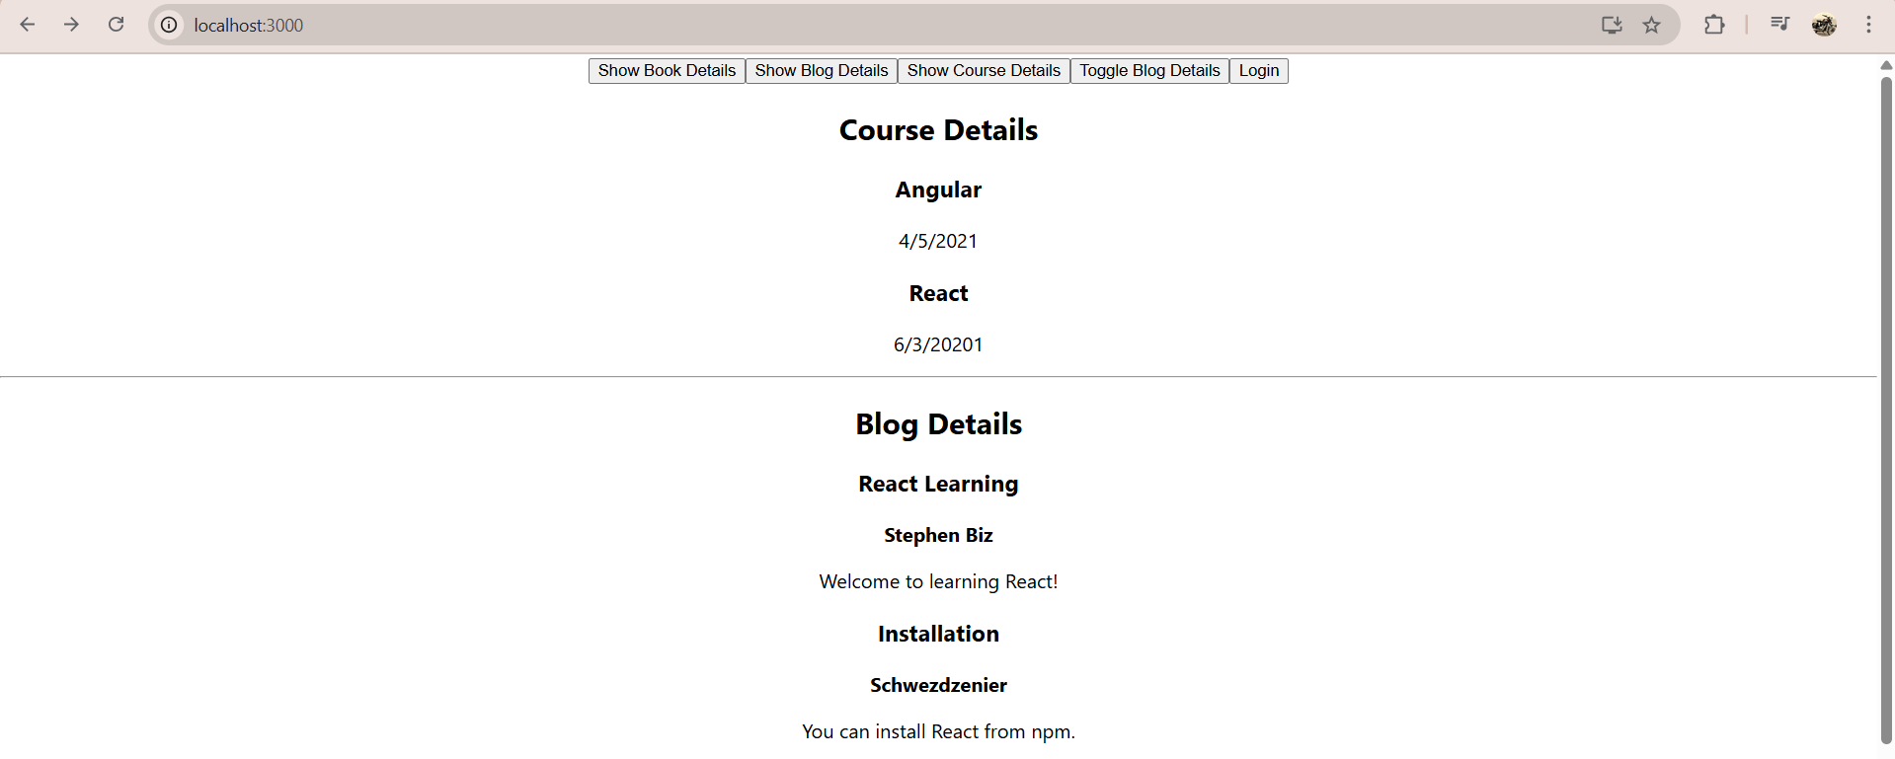

**Book Details**

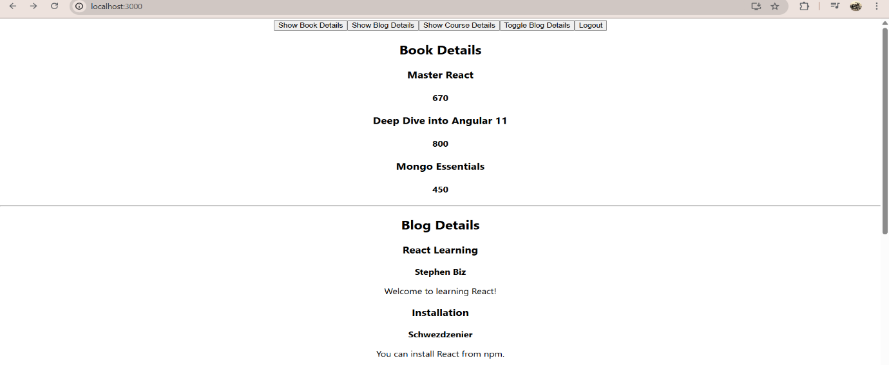

**Blog Details**

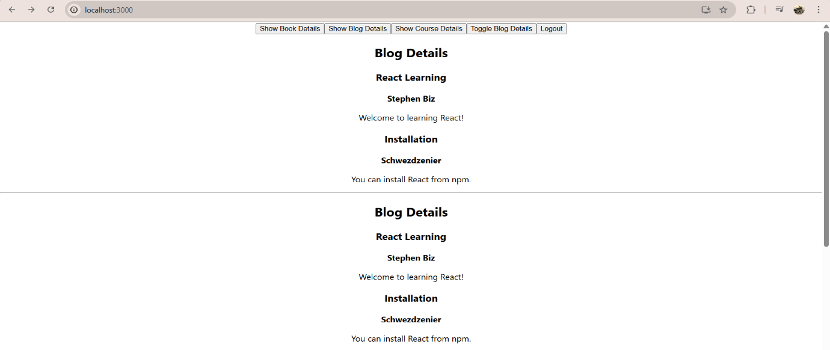

**Toogle Blog**

